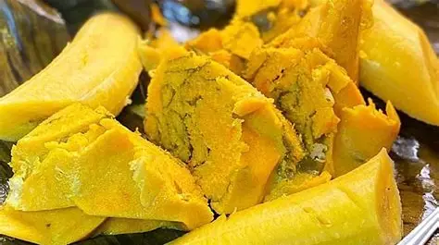
OUR SERVICES
FAST FOOD DELIVERY AGENT
YOU CAN COUNT US

- HOME DELIVERY
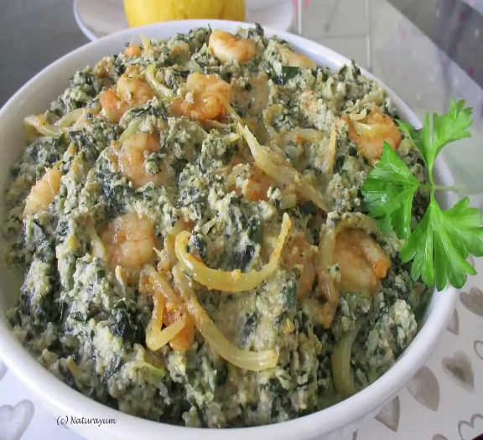
- BREAKFAST DELIVERY
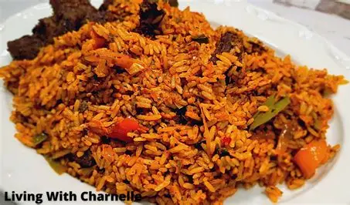
- RESTAURANT SEVICES
- EVENT CATERING
- TAKE AWAY AND DINE-IN

OUR MENU
MAIN DISHES
FRIED RICE
ORDER NOW
FOOD IS READY
FRIED PLATAINS AND NDOLE
ERU
KOKI AND BANANA
ACHU
AND OTHER LOCAL DISHES.
BEVERAGES
COCA-COLA
FANTA AND MANY OTHERS

